Name: Janvi Galani
Class: INFT
Company: LTI
Package offered: 4LPA
LTI had 3 rounds
Coding Round
Technical interview
HR interview

CODING ROUND: 2 Question
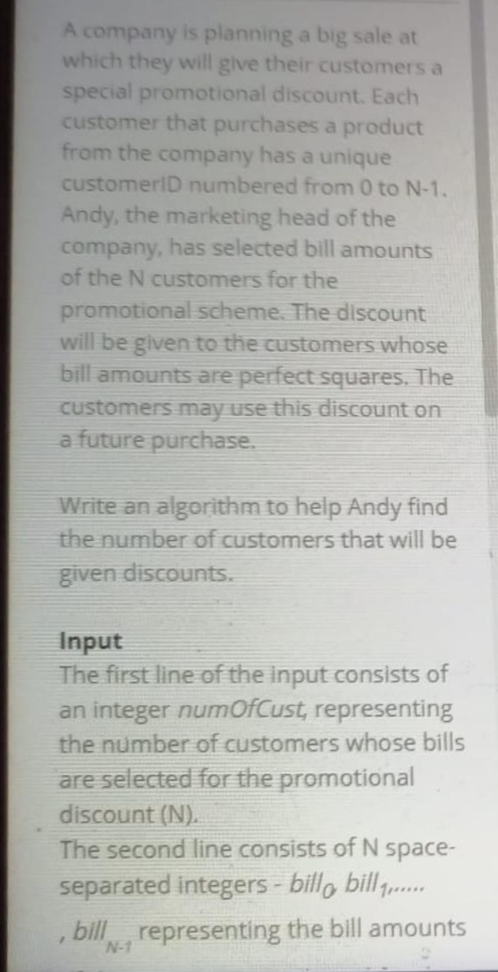

Due to network glitch It was showing me complication time out yet I got selected for another round
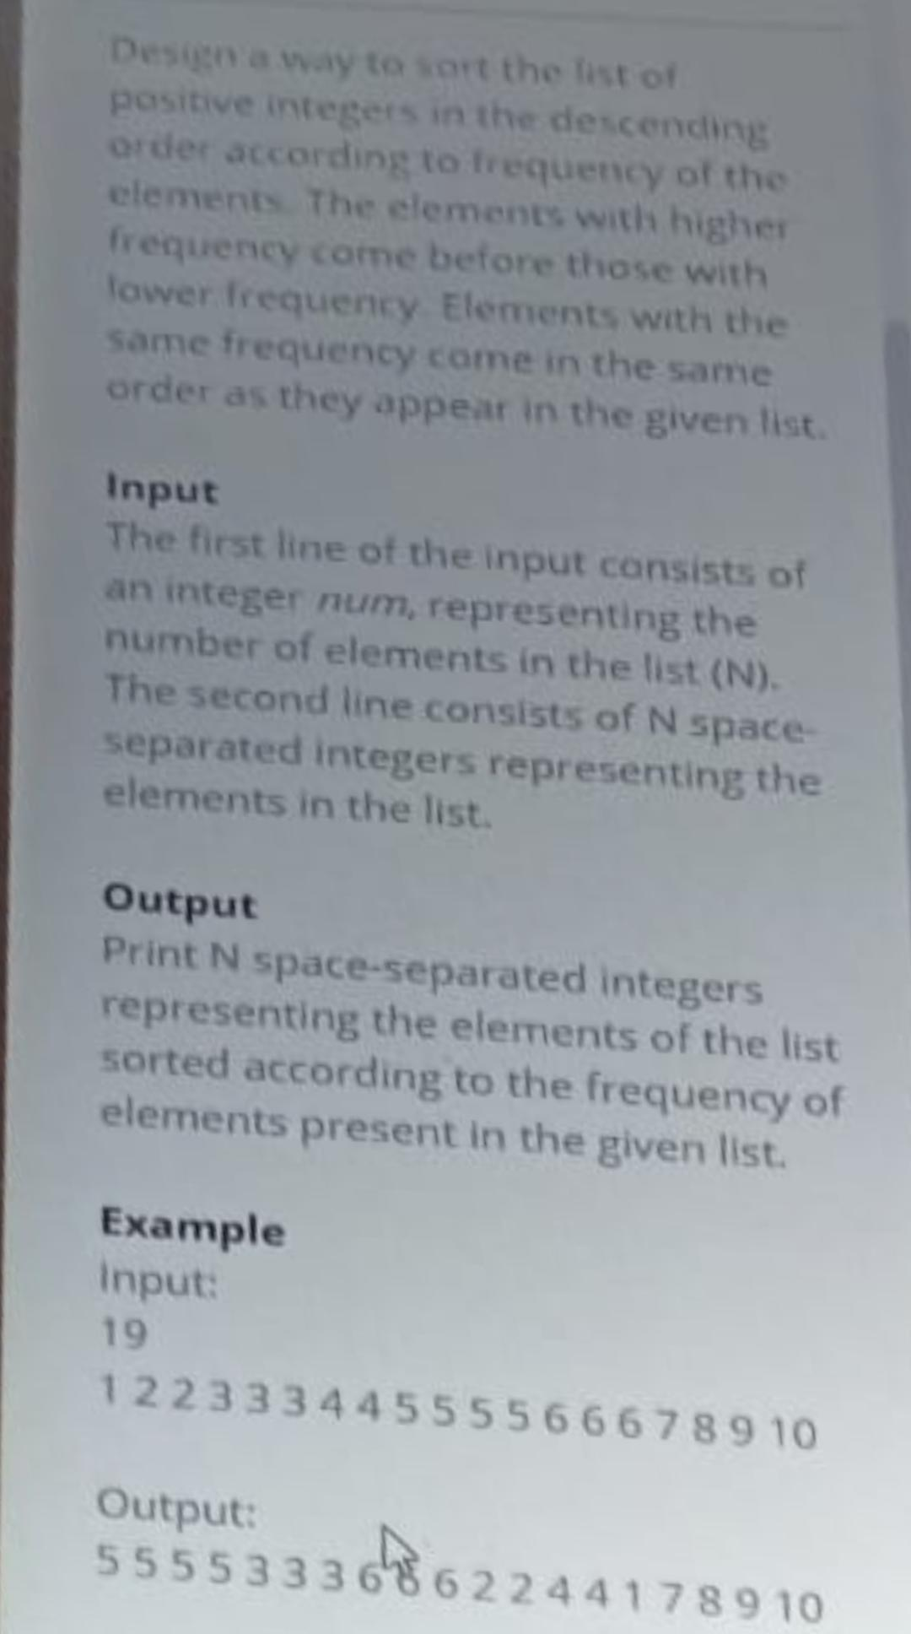

Technical interview: It was based on resume skills and basic Oops concepts were asked
Details on each of the project mentioned in the resume .

HR interview: Mostly it was based on our approach on relocation.
Will your parents permit the idea of relocating
And willingness for further studies.

